ICT Task 1– Project Documentation

Hat Application

Skin Cancer Research Institute – JCU

Presented by

Prabhjot Kaur

Raja Vignesh Virkudi Raghunath

Srikaustubh Mandaleeka

Rohit Targotra

Table of Contents

Part 1 3

Project Description 3

Deliverables 4

Milestones 4

PART 2 4

Client Agreement 4

User Story Log 5

Description about Alfa release user stories 5

Part 3 6

Configuration Management/ Version Control: 6

Project Tools 6

Part 4 7

Testing 7

Prototype 8

Bibliography 12

# Part 1

## Project Description

JCU Skin Cancer Research Unit at present collect data and monitor feedback for sun protection habits across schools. Volunteers with verified ‘*blue card’* are eligible to take up this task at school and record the Hat wearing compliance rates which includes students, teachers and parents. With an aim to do background verification on volunteers, existing native app is available only for *“Blue card approved volunteers”*. With the advent of responsive web design and its inherent advantages over native app, it would be effective if the current Hat wearing application is rendered within a browser providing broader compatibility and being cost-effective. The main idea of this project is to tackle the existing Android app that limited reach of client’s research. Further, developing a browser based web app making it more convenient for volunteers to record data. With an aim to deliver content, establish a broad mobile presence and shared between multiple users, mobile-friendly responsive website is the logical choice.

At present in the existing android app, verified (authenticated) volunteers will get link to download app through e-mail once blue card is approved thus lagging *Immediacy* i.e. In a responsive website contents are easily and instantly accessible to users via a browser across different platforms (iPhone, Android, BlackBerry, etc.) whereas, the existing android app for Hat Application volunteers needs to install the app from an app market place before viewing the content, acting as a barrier between initial engagement and action. Recording User data in frequent intervals by multiple users being the motive, the flexibility to update content must be given prior importance in this scenario i.e. *Upgradability*; An ability to update instantly. Further, Certain factors such as *reachability, share ability, time and cost, support and maintenance* are to be considered when comparing mobile app and browser based app. With an ability to integrated URL’s with multiple mobile technologies such as SMS and QR codes, browser based app does not only help in share ability but saves maintenance costs of an app which is more expensive compared to a website. Taking all these factors into consideration, we are developing a browser based app for Hat Application where it will change the existing methodology to download app rather we will develop a browser based responsive content of the Hat Application embedded into an URL under an existing website JCUB ITGROUP. (Summerfield)

## Deliverables

The above application will be hosted on client’s desired hosting portal, bluehost.com

Further *Source Code, documentation and database* will be delivered to the client.

## Milestones

# PART 2

## Client Agreement

Client’s agreement has been attached in a separate file in the main folder. Alternatively, attaching the e-mail from client were planned alpha-release application was approved. (Figure 1)

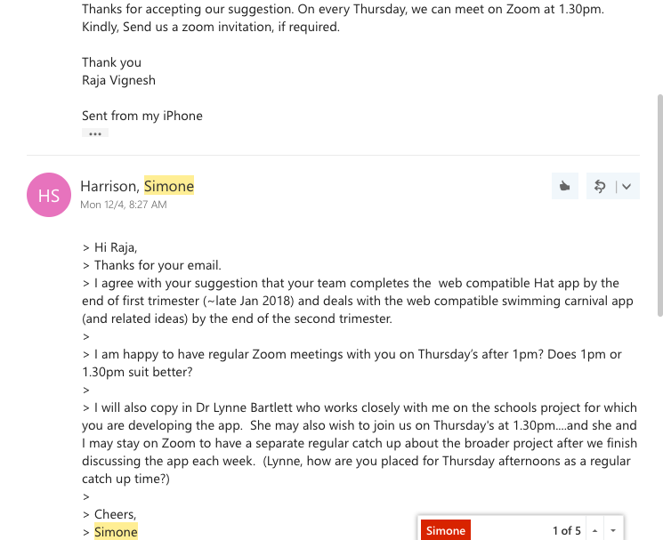

Figure 1

## User Story Log

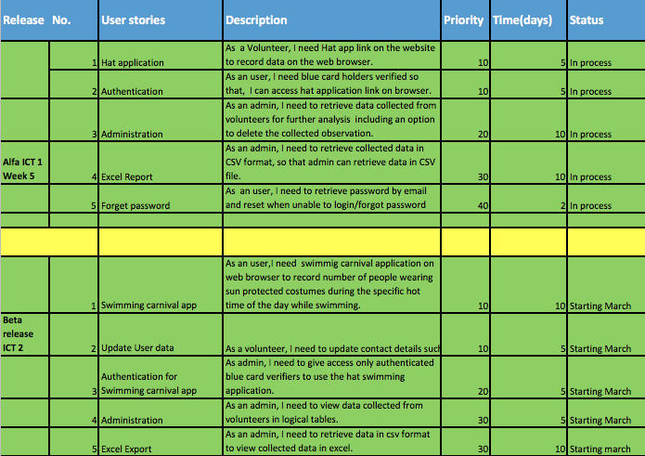

Figure 2

Note: Figure 2 is for reference. Excel file can be found on the main folder for reference.

## Description about Alfa release user stories

**Hat Application**

At present, JCU Skin Cancer Research Institute have an android application where the volunteers who record Hat wearing observations at schools (includes parents, Staff and kids) enter data inside the form present in the mobile application. Further, to enrich user experience and considering the limitations of android native application, we are developing a responsive browser based web page which is later embedded into client’s existing URL. Under this webpage the same fields from the existing form will be replicated thereby avoiding additional fields in the form. (Figure 8 & 12)

**Authentication**

The current android application allows only “*verified blue card holders”* to download the application. This being one of our client’s important priority to filter volunteers, we are developing the application considering, Hat Application to be available only to verified/approved volunteers i.e. URL that displays log in screen will be made available only to verified volunteers. (Figure 8)

**Administration**

Data entered in the form by volunteers will be saved in a database which later can be accessed *only* by admin for interpreting the results from the data collected by volunteers. Permissions will be limited only to the admin in Hat application database. Upon client’s request, we are enabling an option to delete the observation collected by volunteers by admin if there are any discrepancies in the observation recorded. (Ref. Figure 5,6 &7)

**Excel report**

For easy interpretation of results in table format, tables in the database can be converted into CSV file. Admin user can import these tables and view the collected data from volunteers on Excel.

**Forget Password**

In the existing android Hat Application, user (volunteers) will not be able to access the portal if password forgot/lost making it difficult for volunteers to retrieve it. This being a major drawback, we are adding this feature on the website making it easy and with a goal to enhance user-experience for volunteers. (Figure 10 & 11)

# Part 3

## Configuration Management/ Version Control:

As a part of software configuration management, *Github* is being used as our configuration management tool having all our team member’s as contributors to the Skin Cancer Research repository enabling all the members to pull/push besides cloning to the Master folder at the end. (Figure 3)

Figure

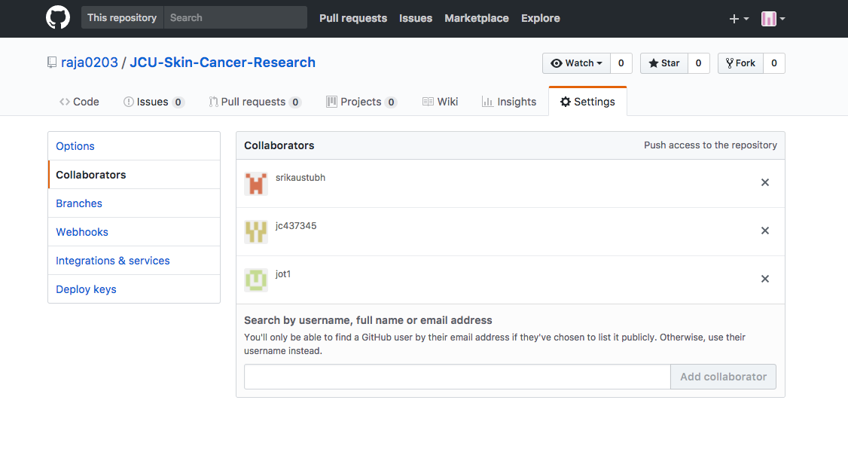

## Project Tools

1. IDE – We will use Xampp as our Integrated Development Environment
2. Programming Languages – PHP, MySQL (For Database), HTML, CSS & Bootstrap.

**Building Tools/ Procedures:**

Slack has been our preferred mode of communication which has been integrated with our Github repository. For day to day updates, Slack is being used between our team members under the workspace “*JCU Skin Cancer Research”*. (Figure 4)

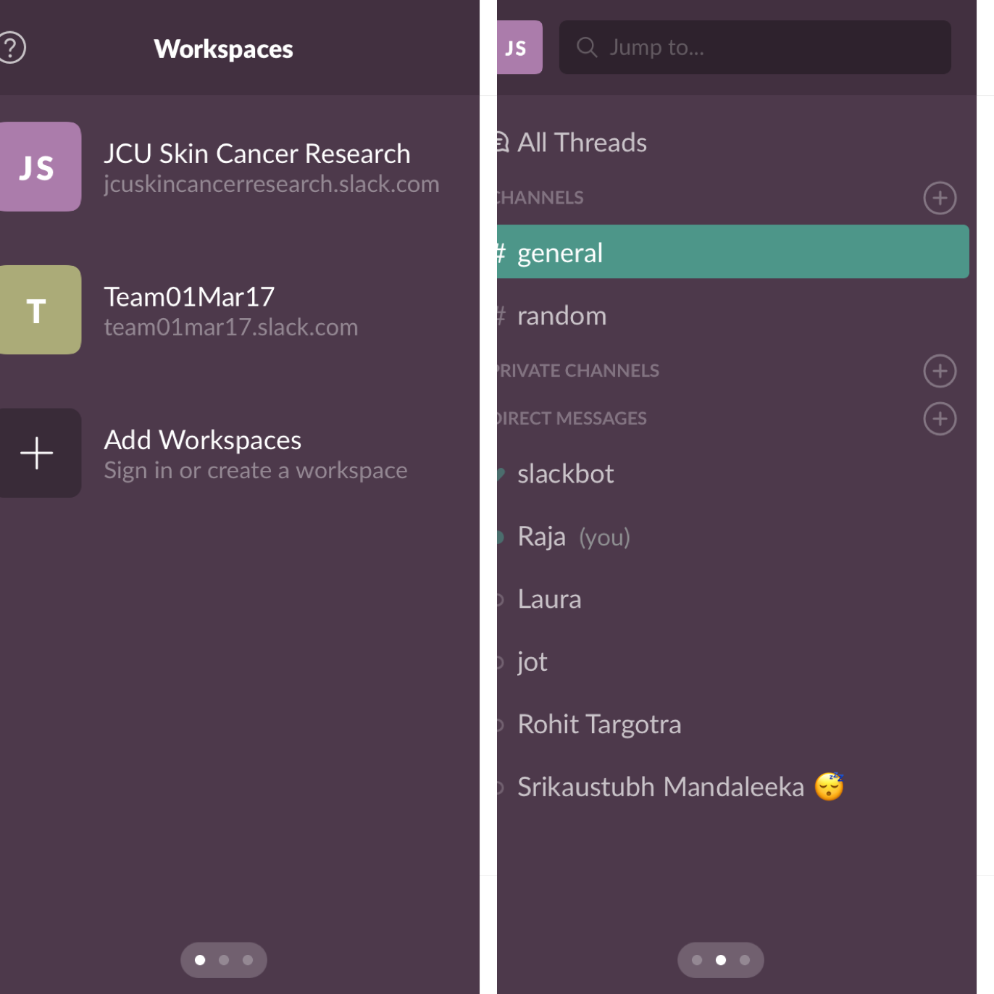

Figure

# Part 4

## Testing

As we are developing the Hat Application on PHP, PHPUnit will be used as our testing tool. To determine, if the development products corresponds to requirements besides verifying if it satisfies intended user needs, testing processes are conducted. Finally, the output test results will be interpreted using JSON White BOX testing, refer lecture slide for more information. Fill the following information in this paragraph (IEEE, 2008)

What testing tool are we using ? PHPUNIT

How are we going to test: Using JSON for test data interpretation and describe the process

**Release testing tools :**

File Zilla will be used for uploading the files into the server and following are the credentials

**Web address :** bluehost.com

**Domain name:**  jcubitgroup.com

**Key:** H2O+CACO3

## Prototype

**Admin view**

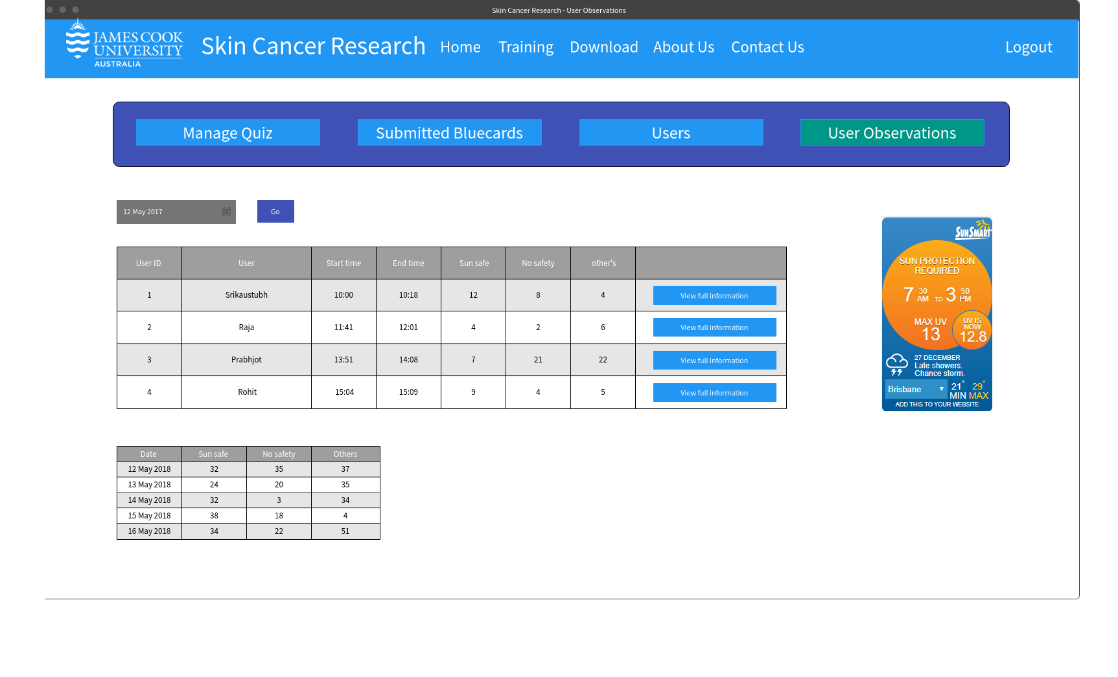

Figure

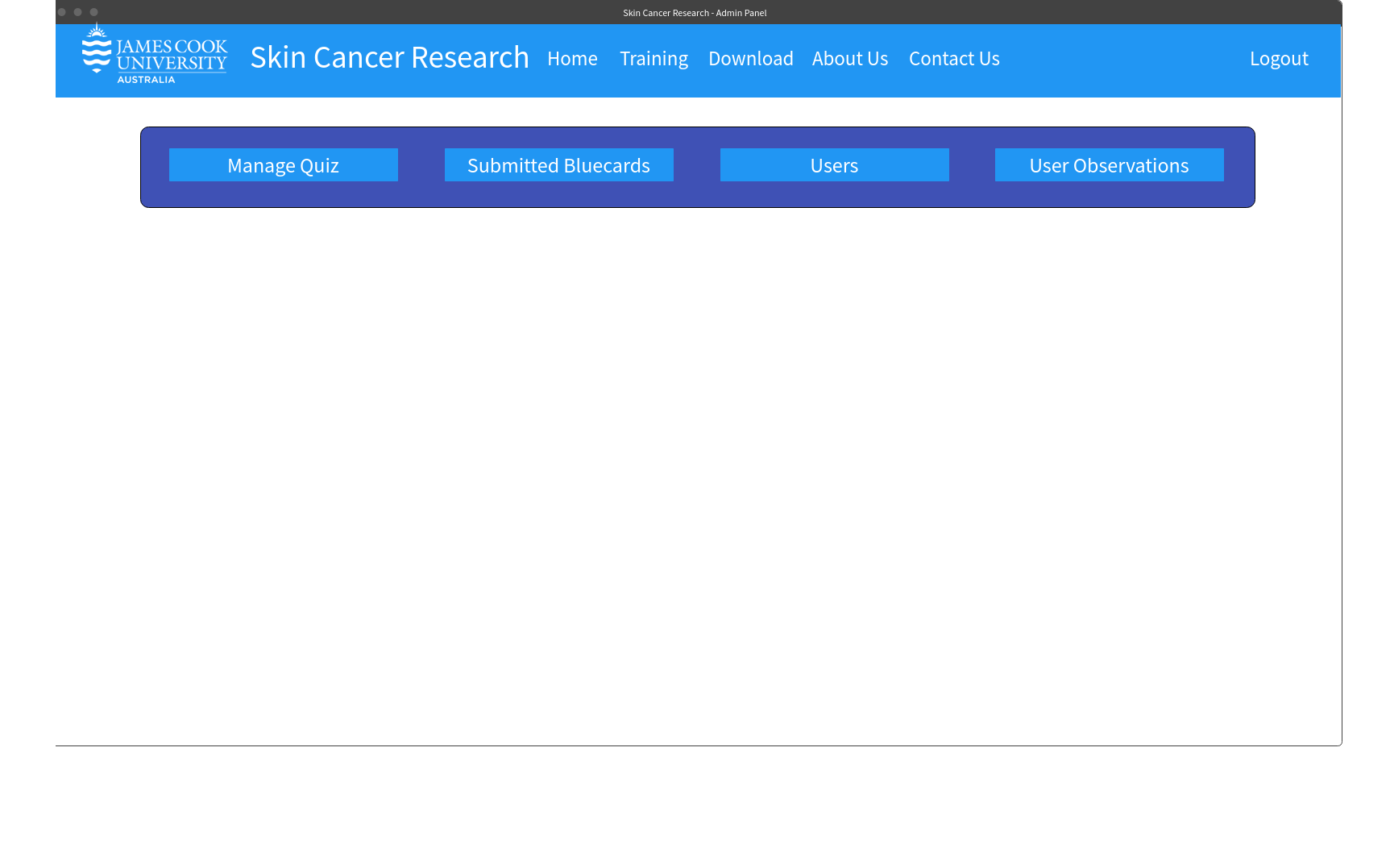

Figure

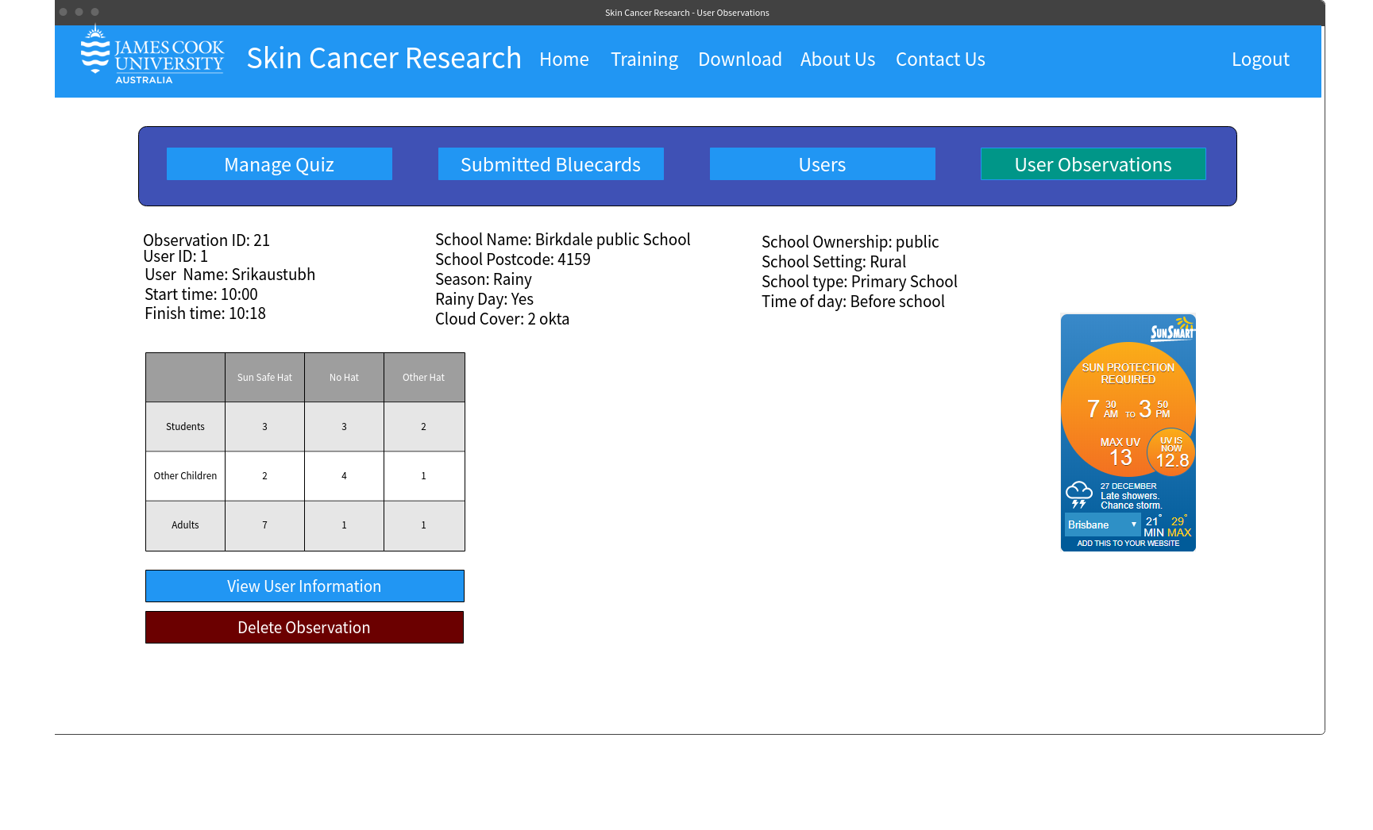

Figure

**Form for volunteers**

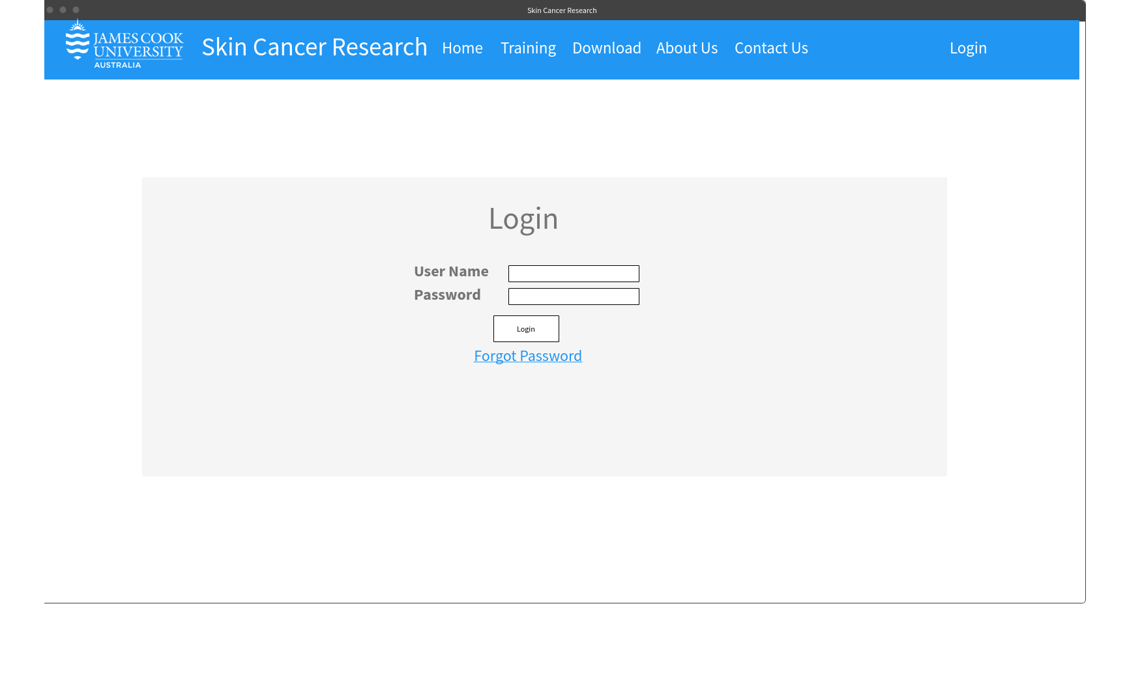

Figure

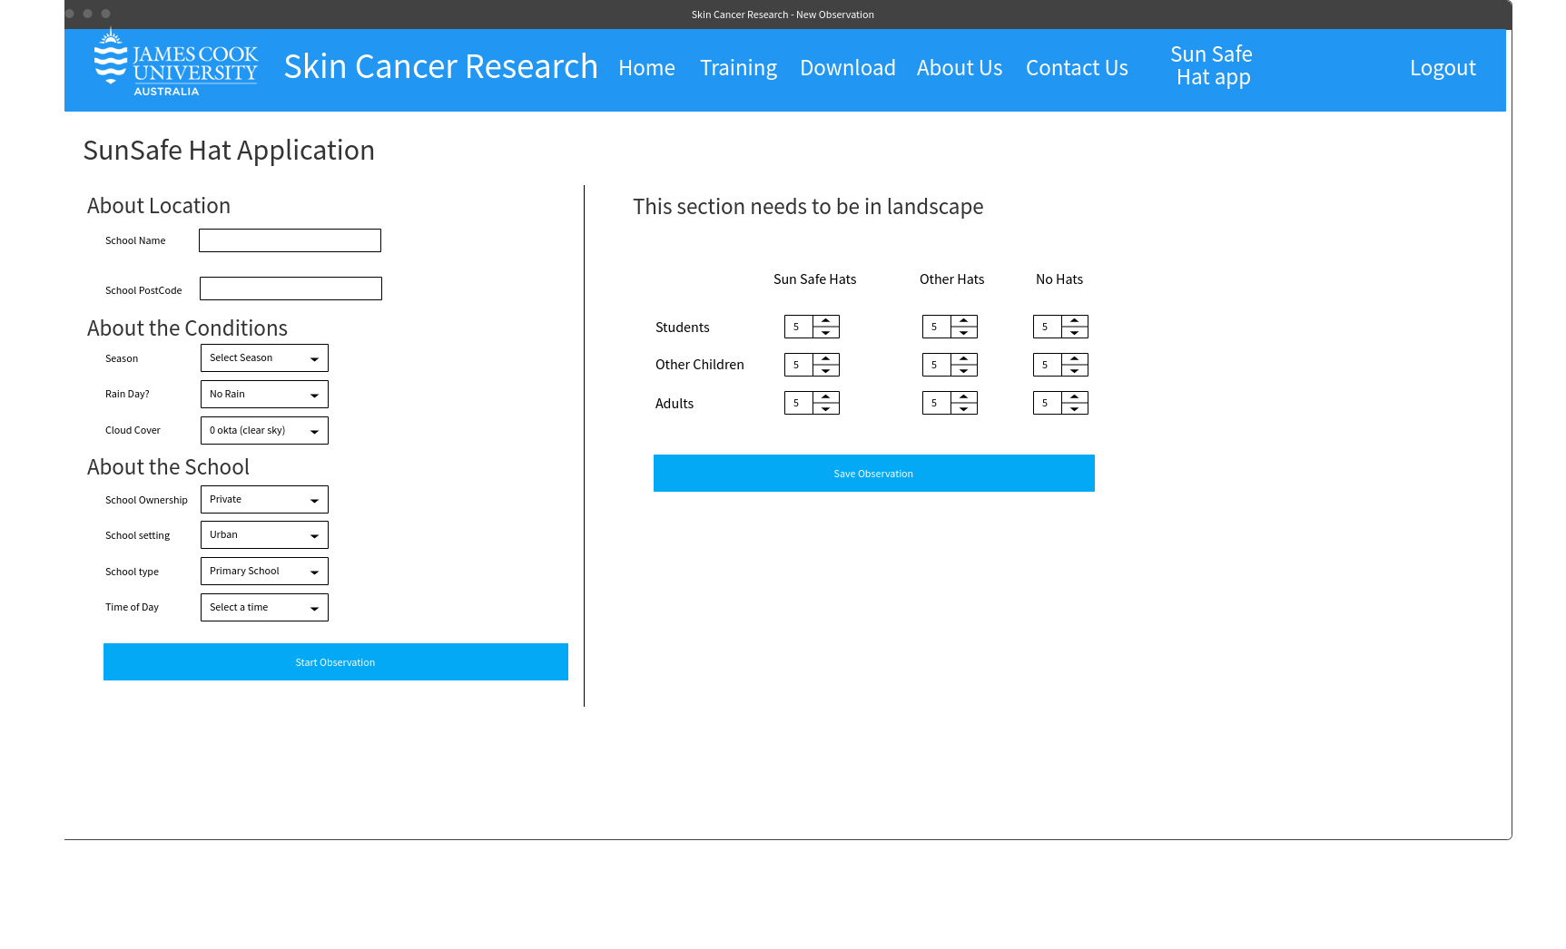

Figure

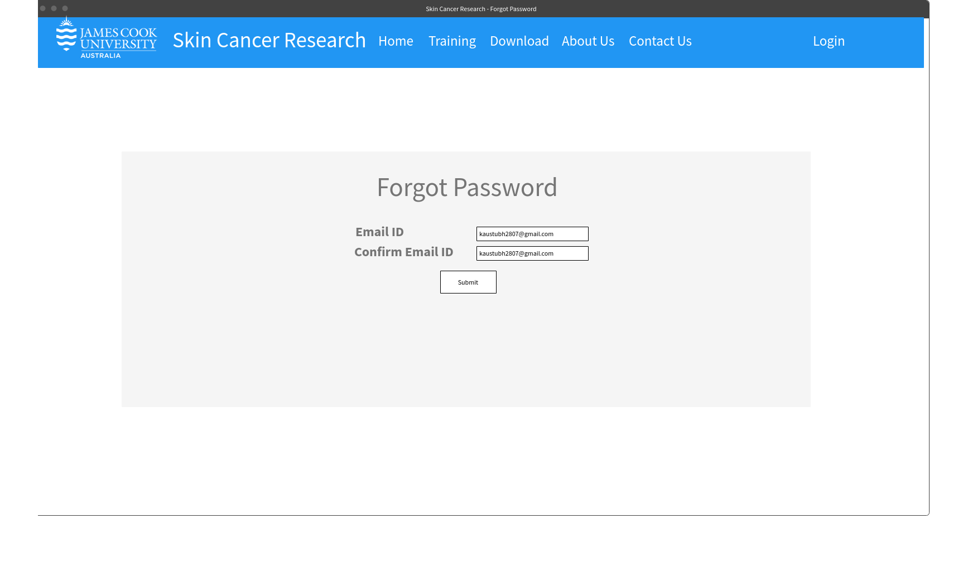**Forgot Password**

Figure

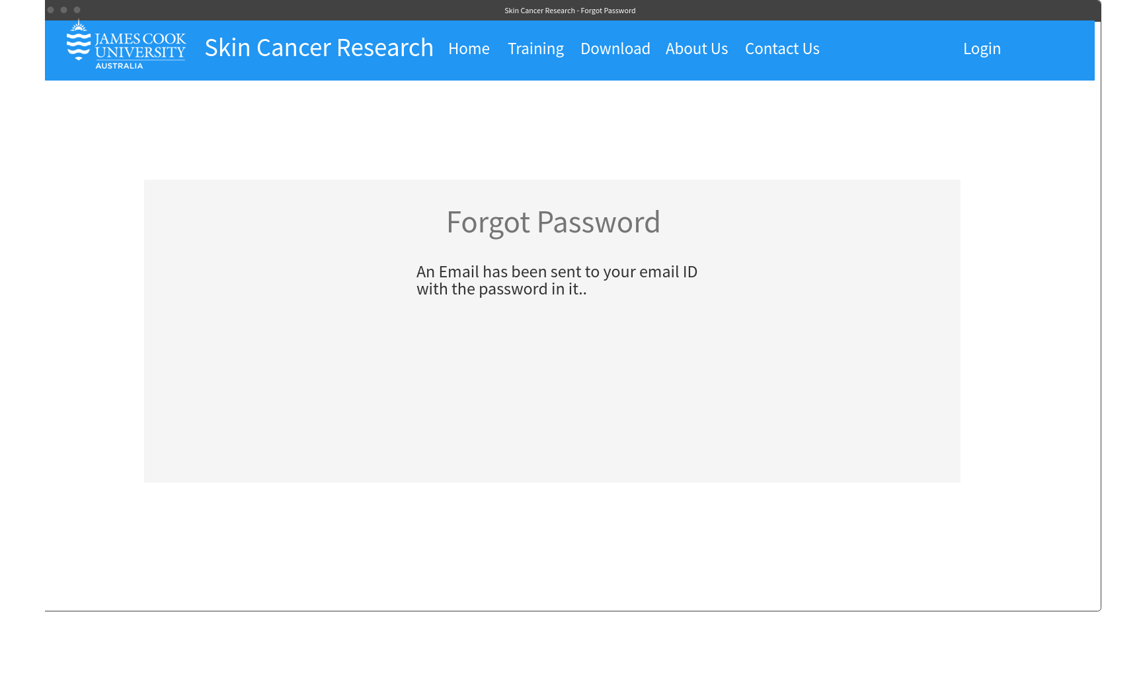

Figure

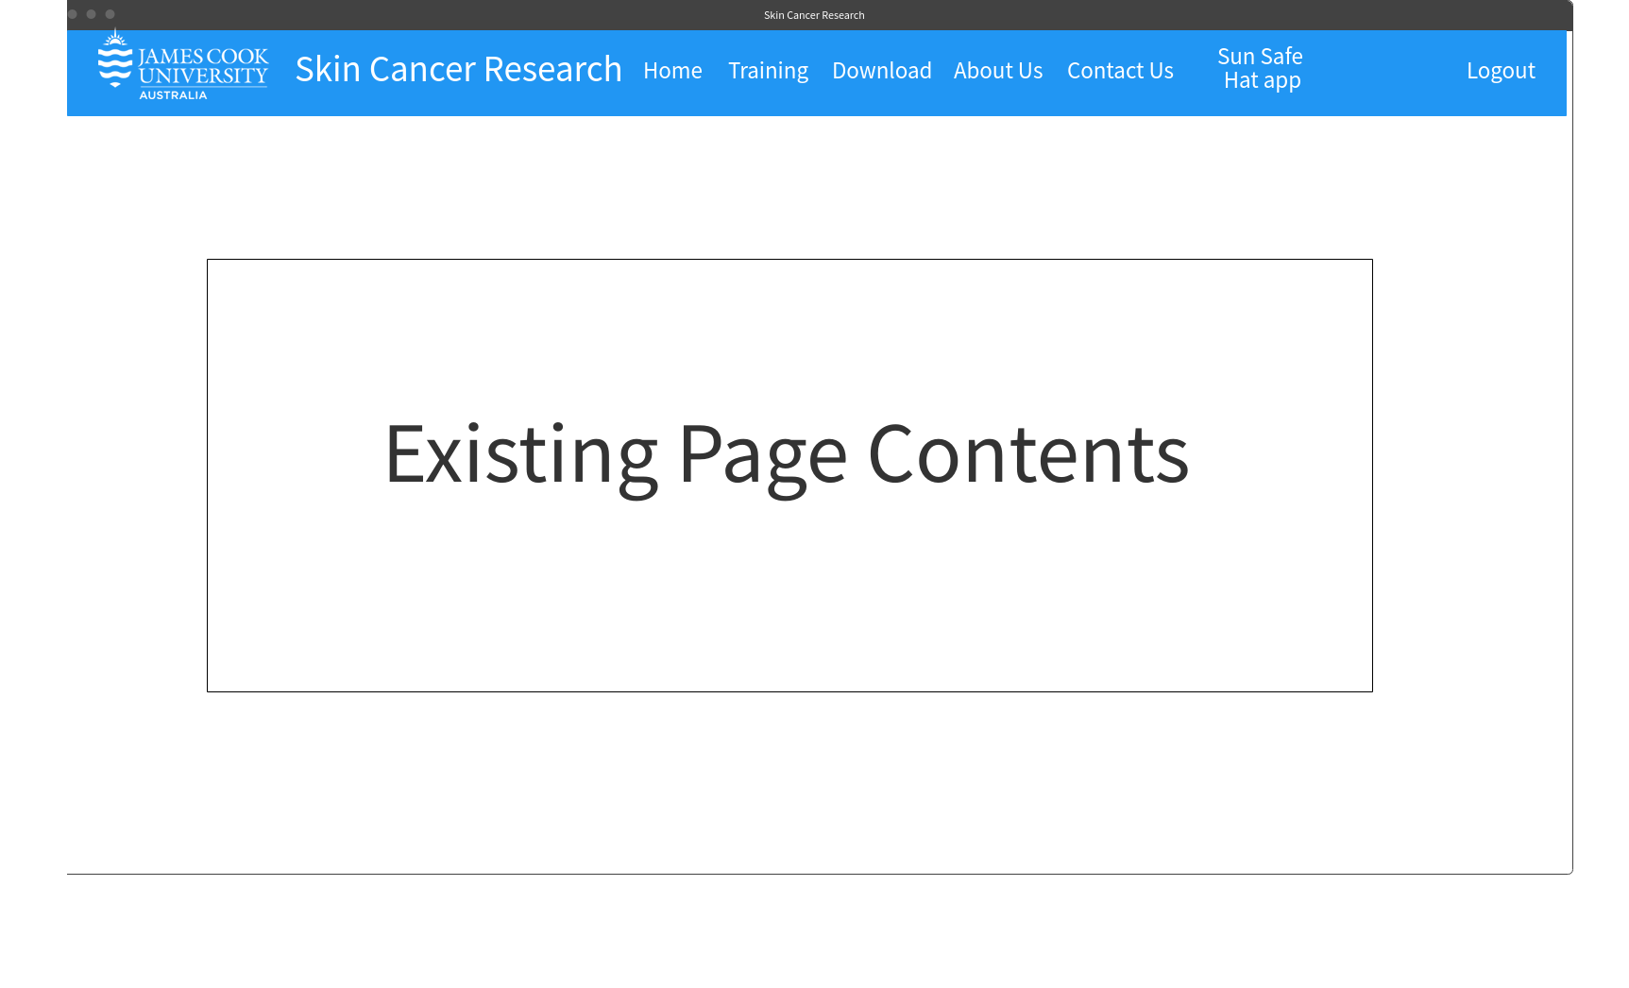**Additional contents**

Figure

# Bibliography

1. Summerfield, J. (2017, 12 25). (Human Service Solutions) Retrieved from https://www.hswsolutions.com/services/mobile-web-development/mobile-website-vs-apps/
2. IEEE. (2008, 7 18). IEEE standard for software and system test documentation.